**Inventory Tracking and Replenishment**

Led the development and optimization of an Inventory Management System using SQL, resulting streamlined operations, improved order fulfillment efficiency. I spearheaded the enhancement of an existing Inventory Management System, focusing on optimizing database performance and improving overall efficiency in tracking, ordering, and managing inventory.

**Skills**:

SQL, Database Design, , Supply Chain Management

**Query 1:** Identifying low-stock products and which product need restocking!!

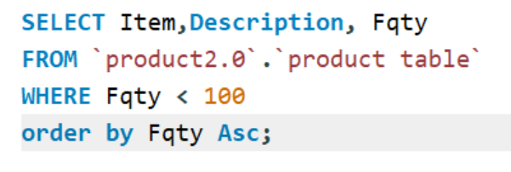

**Output**:

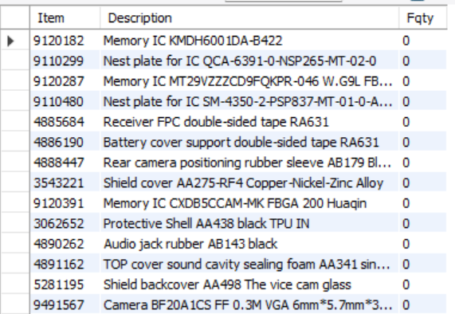

**Query 2**: Distribution of products across categories!!

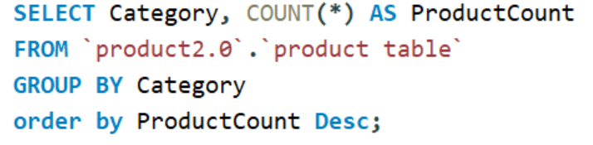

**Output**:

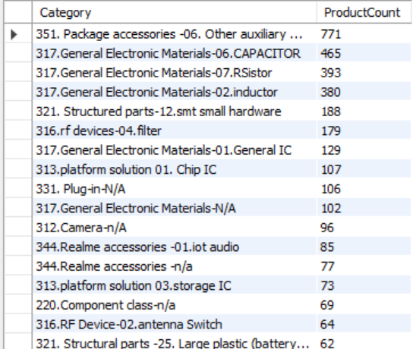

**Query 3**: Filter products by category!!

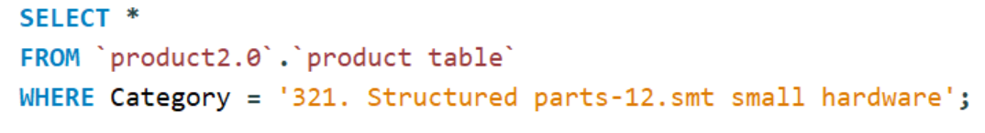

**Output**:

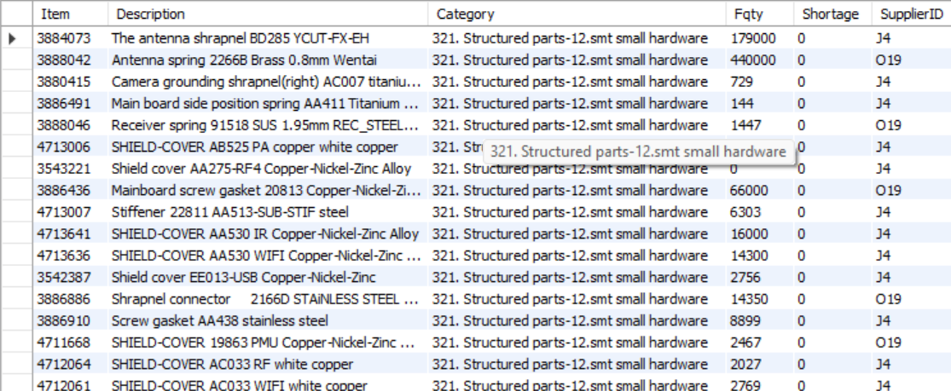

**Query 4:** Determine the number of products supplied by each supplier!!

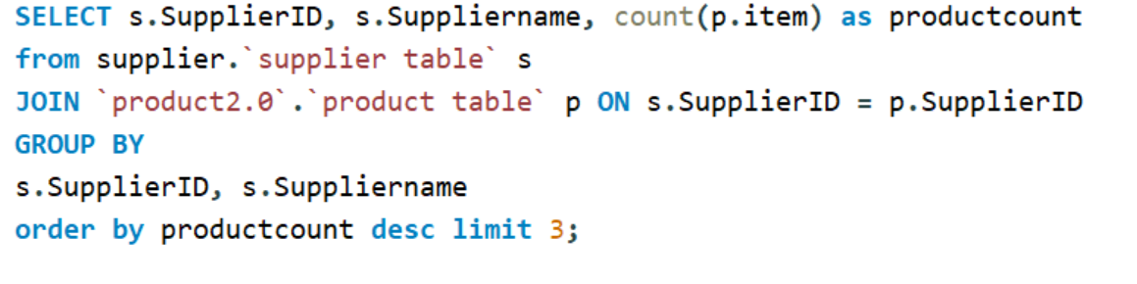

**Output**:

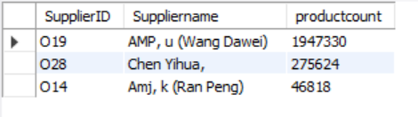

**Query 5**: Analyze shortages to identify products or suppliers that frequently fall short of expected quantities!!

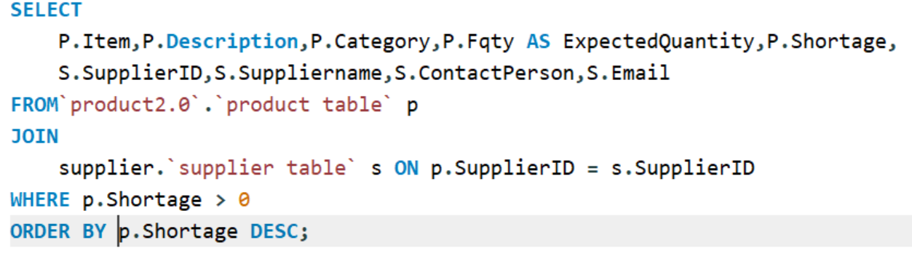

**Output**:

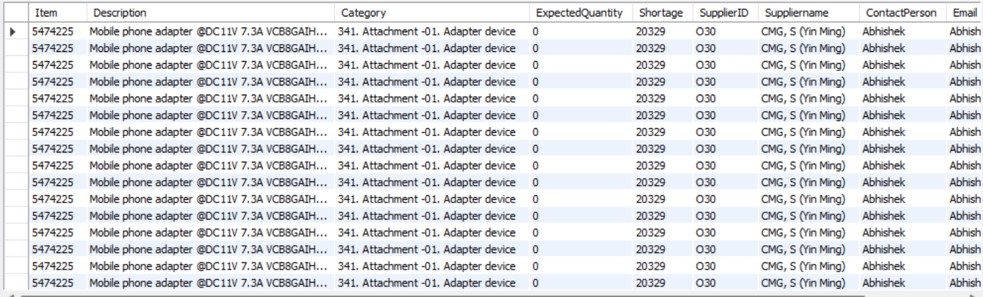

**Query 6**: Identify Suppliers with the Most Shortages!!

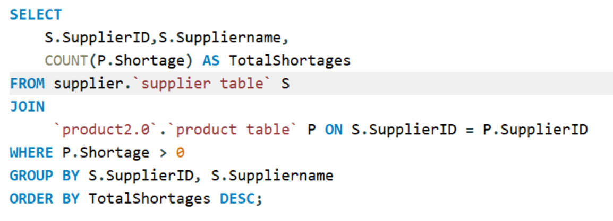

**Output**:

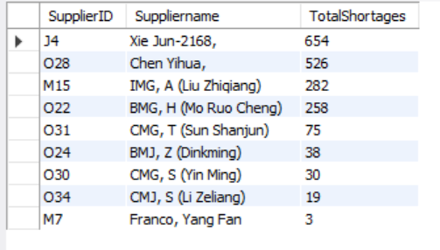

**Query 7:** Find Products with Persistent Shortages!!

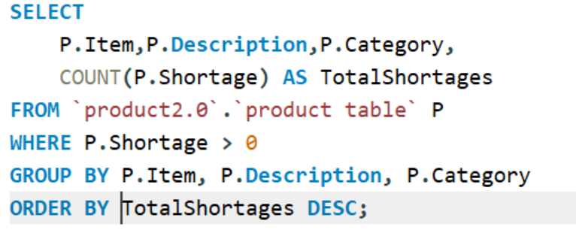

**Output**:

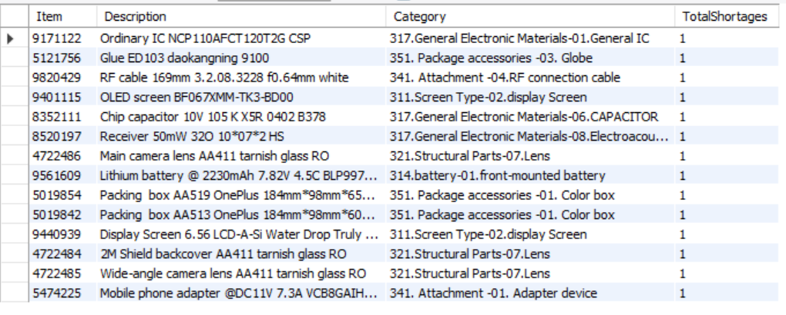

**Query 8**: Calculate Average Shortage Quantity per Supplier!!

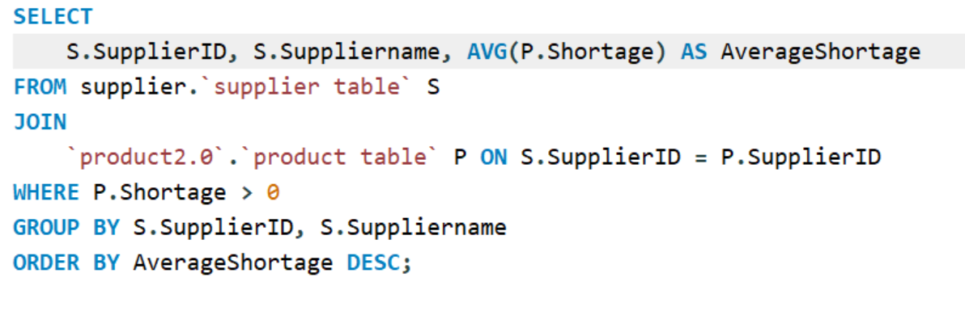

**Output**:

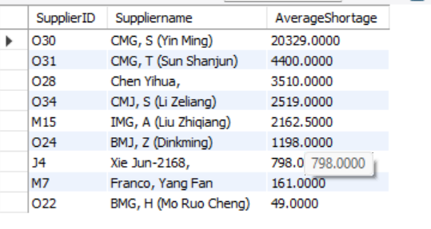

**Query 9:** Explore Shortages in Specific Categories!!:

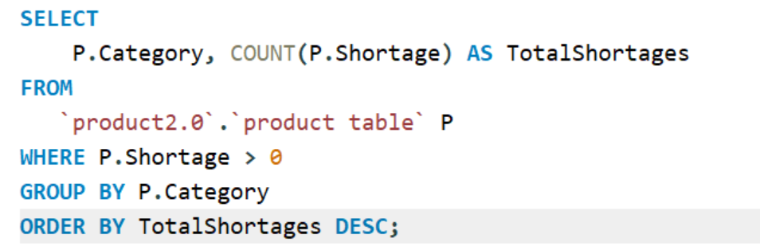

**Output**:

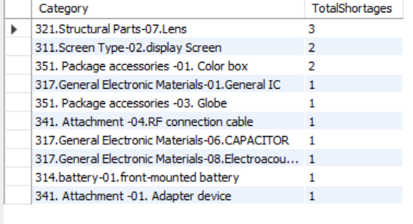

**Query 10**: Identify Contact Persons Associated with Fewest Shortages!!

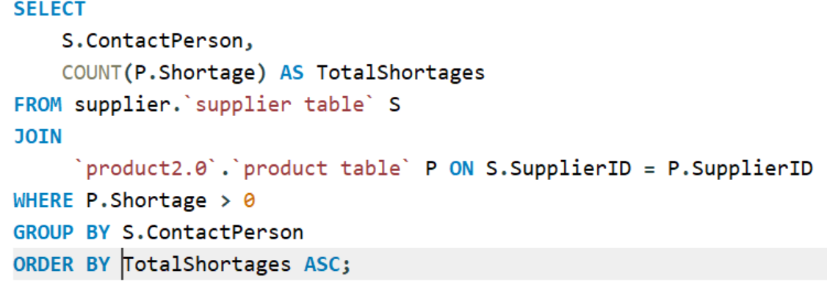

**Output**:

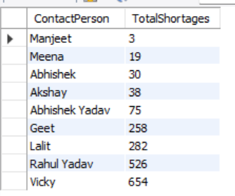

**Conclusion**

In the course of implementing the Inventory Tracking and Replenishment SQL project, several crucial insights have emerged—

* The project's SQL queries have empowered us to make informed and data-driven replenishment decisions. By calculating the optimal reorder points and quantities, we've achieved a more efficient and responsive supply chain.
* One of the standout outcomes has been a notable reduction in stockouts. With the ability to identify low-stock products and determine precise restocking needs, we've minimized instances where products are unavailable to meet customer demand.
* By having a clear understanding of restocking needs, we've strengthened our collaboration with suppliers. This has increased smoother communication, improved lead times, and enhanced the overall efficiency of our supply chain relationships. We were easily able to connect with responsible person of respective supplier company from which we are getting material short consistently.
* Optimizing inventory levels based on demand patterns has led to increased efficiency in inventory turnover. This, in turn, contributes to cost control by minimizing carrying costs associated with excess stock.

The insights gained from this project form a solid foundation for ongoing improvements in our inventory management processes. By staying committed to data-driven decision-making and the continuous refinement of our strategies, we anticipate sustained improvements in efficiency, cost-effectiveness, and customer satisfaction.